Soil Carbon Storage in Different Species Dominance of Sarawak Mangrove Forest, Malaysia

Chandra I. A.¹, Noraini R.¹, Osumanu H.A.² and Seca G.^{3*},

¹Department of Forestry, Faculty of Agriculture and Food Sciences
²Department of Crop Science, Faculty of Agriculture and Food Sciences
Universiti Putra Malaysia Bintulu Sarawak Campus, Nyabau Road, Post Box No. 396
97008 Bintulu, Sarawak, Malaysia
³Department of Natural Resource Industry, Faculty of Forestry and Environment, Universiti Putra Malaysia, 43400 UPM Serdang, Selangor Darul Ehsan, Malaysia

Abstract: Soil carbon contain almost 75% of carbon pool on land which is three times higher than the number of carbon stored in living plants and animal. Carbon storage in forest ecosystems involves inordinate components including plant biomass carbon and soil carbon that can indicate the current status and determined the characteristics of mangrove forest. In the last decade, strong evidence about significant differences among mangrove soils due to the presence of different mangrove species has been arise. Soils of Awat-Awat mangrove forest were collected in 10 different plots with different species dominance using a peat auger at dept of 0-50 cm. The samples were weighted on green weight and after oven drying. The total carbon content of oven-dried soil samples were then analyzed using CHNS analyzer (TruSpec Micro Elemental Analyzer (NCHS), LECO, USA. Soil carbon content of Awat-Awat mangrove forest varied in each plot. The different of species dominance gave different range of results of carbon content. The highest soil carbon content in Awat-Awat mangrove forest was found in soil under dominance of Rhizophora mucronata with 6.24% whereas the lowest one was found 1.73% in soil under dominance of Sonneratia alba.

Keywords: soil carbon storage, soil carbon, species dominance, mangrove forest.

INTRODUCTION

Carbon is the one of the primary sources of life on earth. It is found in all living organism and available in many forms, majority as tree biomass, soil organic matter and as gasses (CO₂) in the atmosphere. Carbon is also the major component of soil organic matter, but its content can vary from 48 to 60% or more of the weight of soil organic matter (Tan, 2005). Carbon storage in forest ecosystems involves inordinate components including biomass carbon and soil carbon (Lal, 2005). Along with soil properties such as soil chemical properties, it can indicate the current status and determined the characteristics of tested mangroves soil. In addition, soil carbon contain approximately 75% of the carbon pool on land and it is three times more than the number of carbon stored in living plants and animal (Lal, 2005).

Sequestration of carbon along with other aggressive conservation efforts helps to mitigate the increasing ne
Corresponding author: Seca Gandaseca, Department of Natural Resource Industry, Faculty of Forestry and Environment, Universiti Putra Malaysia, 43400 UPM Serdang, Selangor Darul Ehsan, Malaysia.

gative impact of global warming on the environment and mangroves as the coastal forest. Sequestration of carbon also play an substantial role in global carbon cycling because they store a large stock of carbon as well as potential carbon sinks and sources to the atmosphere (Muukonen and Heiskanen, 2007). Furthermore, in the last decade, strong evidence about significant differences among mangrove soils due to the presence of different mangrove species has been arise. Difference between soil conditions of mangroves can also result from differences in the composition of initial organic inputs from mangrove litter (Lacerda et al., 1994). The main objective of this study was to assess the soil carbon storage in difference species dominance of Awat-Awat mangrove forest, Sarawak, Malaysia.

MATERIALS AND METHODS

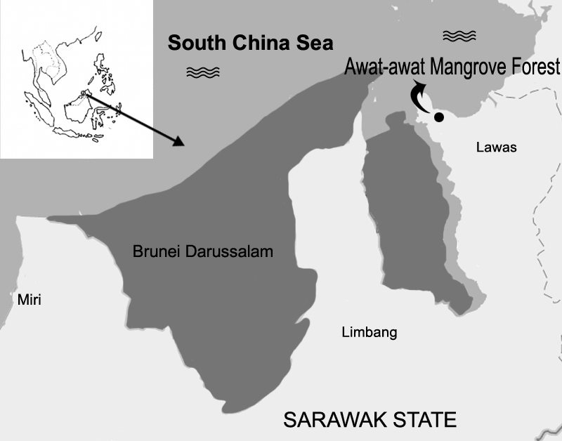
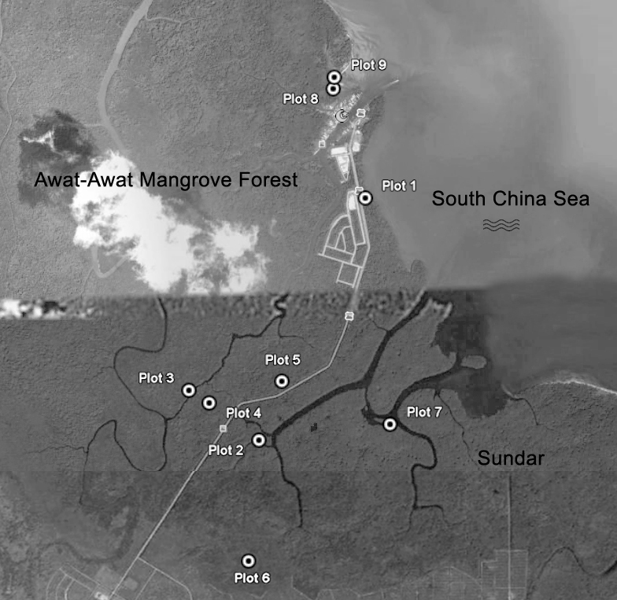
0 2.5km

N

Figure 1: Location of study of Awat-Awat mangrove forest in Lawas, Sarawak, Malaysia.

This study was located in Awat-Awat mangrove forest, Lawas Sarawak, Malaysia, 4º56’N, 115º14’E (Figure 1). Nine plots were established in each area based on different dominance species. Moreover, Rhizophora apiculata Blume is the main species of Awat-Awat mangrove forest, Lawas, Sarawak, Malaysia (Chandra et, al., 2010). Soil sampling was done in November 2012. Soil samples were collected randomly in every plot using a peat auger at a depth of 0 to 50 cm and a total of 32 samples were collected during this study period.

Table 1 Dominant species of each plot in Awat-Awat mangrove forest, Lawas, Sarawak, Malaysia.
Plot | Dominant species | Local name
1 | Rhizophora apiculata | Bakau minyak
2 | Lumnitzera racemosa | Nggeriting putih
3 | Nypa fruticans | Nipah/Apung
4 | L. littorea | Nggeriting merah
5 | Xylocarpus granatum | Nyireh bunga
6 | R. mucronata | Bakau kurap
7 | Bruguiera parviflora | Lenggadai
8 | Sonneratia alba | Perepat
9 | S. caseolaris | Pedada

To prevent and to minimize sample contamination, soil samples collection were placed into closed labeled plastic bag and put into box case at low temperature during transportation. These samples then were air died at room temperature, grinded and sieved with 0.05 mm for further analysis. Soil pH from each plot was determined use the potentiometric method of Tan (2005). The total C content of soil samples was analyzed using CHNS analyzer (TruSpec Micro Elemental Analyzer (NCHS), LECO, USA). Analysis of variance (ANOVA) test at P≤0.05 was used to check the variance of pH and carbon content among the plots and Duncan’s multiple range test (DMRT) were used to show and specify the difference among them.

RESULTS AND DISCUSSION
Soil pH of in every plot of Awat-Awat mangrove forest were acidic with range of 3.93 to 5.41 (Table 2). The most acidic one was found 3.93 in plot 6 soil under R. mucronata dominance. Average pH value in Awat-Awat mangrove forest were lower compared to other research areas that were done by other researchers but still in the comparable values (Table 3). Generally, soils of mangrove are neutral to slightly acidic due the sulphur-reducing bacteria and the presence of acidic clays, but in Malaysia there are mangroves with very acidic brackish waters due to the aeration of soil sulphates, forming sulphuric acid (Peter and Sivasothi, 2001).

According to Duncan’s multiple range test (DMRT), there were 4 grouping of soil pH among 9 plots that were significantly different among each other. It were plot 8 and 9; plot 7 and 9; plot 1,2,3,4,5 and 7; plot 1, 5 and 6. Soil pH in the plot with same group was not significantly different among each other (Table 2).

Soil carbon content of Awat-Awat mangrove forest was vary, ranged from 1.73% to 6.24% with average mean was 3.29%. The highest soil carbon content in Awat-Awat mangrove forest was found 6.24% in soil under dominance of R. mucronata (plot 6) whereas the lowest soil carbon content was found 1.73% in soil under dominance of S. alba. According to DMRT test, there were 5 grouping of soil carbon content which were significantly different among each other whereas soil carbon content with same group was not significantly different (Table 2).

Table 2. Mean of pH and soil carbon content of Awat-Awat mangrove forest at Lawas, Sarawak, Malaysia.
Plot | Species dominance | pH | C Content (%)
1 | Rhizophora apiculata | 4.20 cd | 2.72 cde
2 | Lumnitzera racemosa | 4.65 c | 3.62 bcd
3 | Nypa fruticans | 4.61 c | 4.08 bc
4 | L. littorea | 4.68 c | 2.22 de
5 | Xylocarpus granatum | 4.19 cd | 2.30 de
6 | R. mucronata | 3.93 d | 6.24 a
7 | Bruguiera parviflora | 4.76 bc | 4.60 b
8 | Sonneratia alba | 5.41 a | 1.73 e
9 | S. caseolaris | 5.24 ab | 2.08 de
*Mean with same letter for each variable are not significantly different at P≤0.05 using ANOVA, Duncan’s multiple range test was used to check the differences among the station.

Soil carbon studies of mangrove have been done in many place of the world with many different site characteristics. In present study, carbon content of soil under dominance of R. apiculata in Awat-Awat mangrove forest was comparatively same with carbon content in soil under R. mangle in Sepetiba Bay, Brazil (Lacerda et. al., 1995). Furthermore, the soil carbon content of Awat-Awat mangrove forest was comparable with the values recorded in elsewhere (Table 3).

Studies revealed that the soil carbon content is different and varies from one place to another. Different species dominance gave different result of soil carbon content. Moreover, Lacerda et al. (1995) were also noted for an accumulation of strong evidence for significant differences among mangrove soils due to the presence of different mangrove species in the last decade.

Table 3 Comparison of the found results for C content and pH values of mangroves with other studies
Author | Site Characteristics | C Content (%) | Average pH
Sukardjo (1994) | Mangrove forest of the Apar Nature Reserve, East Kalimantan, Indonesia. With species of Avicennia and Ceriops. | 3.96% (Avicennia forest)  11.40% (Ceriops forest) | 4.35 to 5.29 (Avicennia),  3.70 to 4.20  (Ceriops)
Lacerda et. al. (1995) | Itacuruca Experimental Forest, Sepetiba Bay, Brazil | 2.70% - 2.80% (under Rhizophora mangle) and 3.80% - 6.10% (under Avicennia schaueriana) | -
Shazra et. al. (2008) | Mangrove forest of HA. Baarah, Maldives. With species R. mucronata and Hibiscus tiliacius | 0.196% and 0.017% | 6.0 (R. mucronata),  6.5 (H. tiliacius)
Wakushima et al. (1994)a | Mangrove forest of Amphur Laemngop, Thailand. With species of R. apiculata R. mucronata. C. tagal, Excoecaria agallocha, and Lumnitzera racemosa. | - | 4.27±0.05 to 7.32±0.09
Wakushima et al. (1994)b | Mangrove forest of southern Japan. With species of R. stylosa. | - | 3.31 to 8.16
Ukpong (1995) | Mangrove swamp of southeastern Nigeria. With species of Rhizhophora spp and Nypa fruticans. | - | 2.9 to 3.8
Mahmood H. (2005) | Mangrove forest of Kuala Selangor, Malaysia. With species of Bruguiera parviflora | - | 6.77±0.05 to 7.07±0.04
Muhibbullah et al., (2005) | Sundarband mangrove forest, Bangladesh. With various species. | - | 6.3 to 7.13
Rambok et al. (2010) | Wildlife sanctuary mangrove forest, Sibuti, Malaysia. With species of R. apiculata. | 12.18% | 3.34
Present study | Awat-Awat mangrove forest, Malaysia. With species of R. apiculata | 1.73% – 6.24% | 3.93 to 5.41

CONCLUSION

Soil acidity of Awat-Awat mangrove forest was acidic and varies in each species dominance. The most acidic pH in Awat-Awat mangrove forest was found 3.93 in soil under dominance of R. mucronata. According to ANOVA test at P≤0.05, pH in different species dominance of Awat-Awat mangrove forest were significantly different.

Soil carbon content of Awat-Awat mangrove forest was varies in each species dominance. The highest soil carbon content was found 6.24% in soil under dominance of R. mucronata whereas the lowest soil carbon content was found 1.73% in soil under dominance of S. alba. The difference of species dominance in Awat-Awat mangrove forest gave the different result of pH and soil carbon content.

REFERENCES

Chandra I.A., Seca G. and Abu Hena M.K. 2011. Aboveground biomass production of Rhizophora apiculata Blume in Sarawak mangrove forest. American Journal of Agricultural and Biological Sciences, 6 (4): 469-474.
Lacerda, L. D., Ittekkot, V. and Patchineelam, S.R. 1995. Biogeochemistry of mangrove soil organic matter: a comparison between Rhizophora and Avicennia soils in South-eastern Brazil. Estuarine, Coastal and Shelf Science 40: 713-720.
Lal, R. 2005. Forest soil and carbon sequestration. Journal Forest Ecology Management 220: 242-258.
Mahmood H., O. Saberi, B. Japar Sidik, K. Misri. 2005. Net primary productivity of Bruguiera parviﬂora (Wight and Arn.) dominated mangrove forest at Kuala Selangor, Malaysia. Forest Ecology Management 255: 179-182.
Muhibbullah, Md., S.M. Nurul Amin, A.T. Chowdhury. 2005. Some psysico-chemical parameters of soil and water of Sundarban mangrove forest, Bangladesh. Journal of Biological Sciences 5(3): 354-357.
Muukonen, P and J. Heiskanen. 2007. Biomass estimation over a large area based on standwise forest inventory data and ASTER and MODIS satellite data: A possibility to verify carbon inventories. Remote Sensing of Environment 107: 617-624.
Peter K. L. N. and N. Sivasothi. 2001. A guide to mangroves of Singapore. http://mangrove.nus.edu.sg/guidebooks/text/1015a.htm.
Rambok, E. Seca G. and Osumanu H. A. and Nik Muhamad A. M. 2010. Comparison of selected soil chemical properties of two different mangrove forests in Sarawak. American Journal of Environmental Sciences, 6 (5): 438-441.
Shazra, A., Rasheed, S. and Ansari, A.A. 2008. Study on the mangrove ecosystem in Maldives. Global Journal of Environmental Research 2 (2): 84-86.
Sukardjo, S. 1994. Soils in the mangrove forest of the Apar Nature Reserve, Tanah Grogot, East Kalimantan, Indonesia. Southeast Asian Studies 32 (3): 385-398.
Tan, K.H., 2005. Soil sampling preparation and analysis. 2nd Ed., Taylor and Francis, New York, pp: 623. ISBN: 0-8493-3499-3
Ukpong, L.E. 1995. Vegetation and soil acidity of a mangrove swamp in southeastern Nigeria. Soil Use and Management 11(3): 141-144.
Wakushima, S., S. Kuraishi, N. Sakurai, K. Supappibul, S. Siripatanadilok. 1994a. Stable soil pH of Thai mangroves in dry and rainy seasons and its relation to zonal distribution of mangroves. Journal of Plant Research 107: 47-52.
Wakushima, S., S. Kuraishi, N. Sakurai. 1994b. Soil salinity and pH in Japanese mangrove forests and growth of cultivated mangrove plants in different soil conditions. Journal of Plant Research 107: 39-46.

ACKNOWLEDGEMENT

We wish to thank University Putra Malaysia for funding this research funding project. We also want to appreciate Sarawak Forestry Department, Miri Forestry Department for their help during fieldwork. Last, we want to thank all the staff of Department of Forest Science and Department of Crop Science UPMKB for their help during fieldwork and laboratory experiment.

